Chapter 4 cells and Human reproduction

4.1 Cells

Cells
- 1 cell organisms: unicellular organisms
- >1 cell organisms: multicellular organisms

Plant cell | animal cell
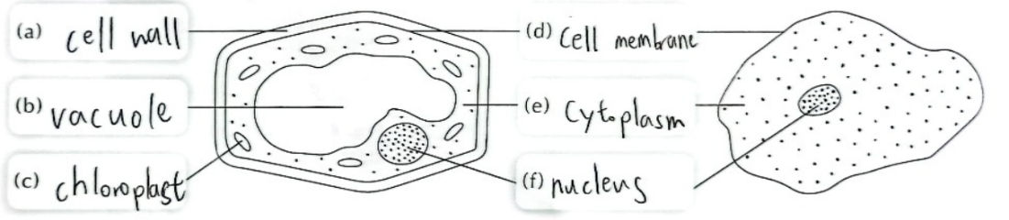
This is a biological drawing
- Be proportional
- Use pencil
- Label with ruler don’t cross lines
- use dots to represent darker
- give a title and write the magnification
observing cells
- iodine/methylene blue solution: to stain the cells

DNA (deoxyribonucleic acid)
- chromosomes (thread like) in nucleus contain DNA and proteins
- human have 23 pair (46) chromosomes
(22 pair of autosomes + 1 pair of sex chromosome)
- male XY female XX
cell division
- cell -> cell division -> daughter cells
- genetic material in nucleus duplicate
- nucleus divides
- cytoplasm divides
- 2 daughter cells
- Grow and loop

Microscope
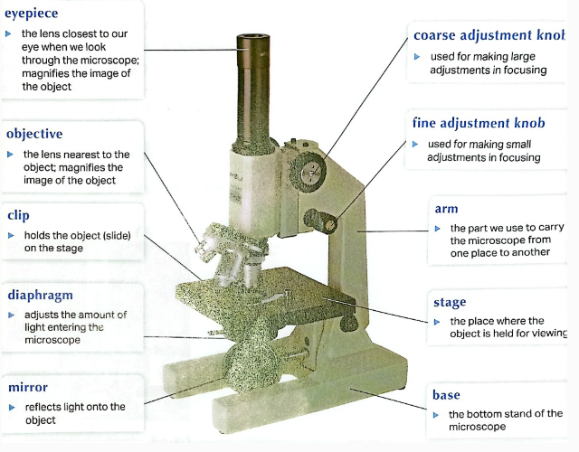
- Light microscope
- Electron microscope
- Magnification of microscope = magnification of eyepiece x magnification of objective
Using a microscope
- Place near a Lightsource
- Choose low power objective and eyepiece
- Adjust the mirror and watch with both eyes open
- Look through with both eyes open
- Look from the side and lower the coarse adjustment knob until just above the slide
- Look through and turn coarse adjustment knob until you see a clear image
- Turn fine adjustment knob until you get the sharpest image
Special properties
- Slide with p d
- Inverted movement

4.2 Cell organisation

Cell differentiation
- Different cells are specialized for different things (e.g. carrying messages, movement, carrying oxygen)
- All comes from one stem cell
- Can differentiate into different types of cells
- Called cell differentiation
Different cells
- Animal cells
  - Nerve cells: Long and have many branches, carries messages
  - Skin cells: flat and close together -> a good protective layer for the body
  - Fat cells: stores fat to keep body warm, nucleus is pushed to cell membrane
- Plant
  - Leaf cells : contain chloroplasts for photosynthesis
  - Transporting cells : long and tube shaped, transport water, nutrients and minerals
  - Root hair cells : increases surface area of root so more water can be absorbed

Level of organisation
Cell ->tissue->organ->system->organism
Tissue
- Group of similar cells working together
- Human e.g. : muscle tissue, nerve tissue, bone tissue
- Plant e.g. : vascular tissue, epidermal tissue (for protection)

Organ
- Tissue group together to form an organ
- E.g. muscle tissue+ blood tissue + bone tissue= heart
System
- Organ group together to form system
- E.g. digestive system, breathing system, reproductive system, nervous system, circulatory system
e.g. Muscle cells Muscle tissues heart circulatory system human

4.3 human reproduction

Human sex cells
- Living things produce offspring (son)
- Human: sexual reproduction
- Fusion of sperm and ovum
Sperms
- Looks like a tadpole
- Nucleus inside head
- Nucleus carries genetic material from male
- tail -> swim
Ova
- surrounded by a jelly coat
- nucleus contain genetic material from female
- cytoplasm contain food
- cannot move itself
 | Male |  | Female
 | Body cell | Sex cell(sperm) | Body cell | Sex cell(ovum)
Chromosomes | 23 pairs | 23 | 23 pairs | 23
Autosomes | 44 | 22 | 44 | 22
Sex chromosomes | XY | Half: X  Half: Y | XX | X

Human reproductive system
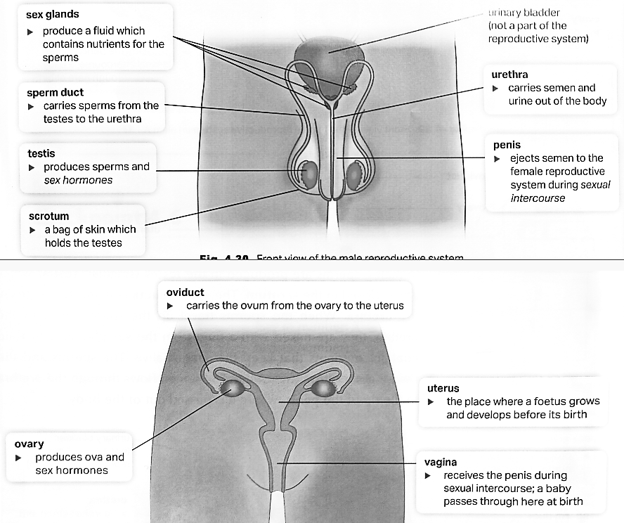

Ovulation
- Ovaries produce ova -> one ovum is released into the oviduct every month
- Move through the oviduct to the uterus

Process of human reproduction

Fertilization
- During sexual intercourse, the husband inserts their erect penis into the vagina
- Semen is ejected into the vagina
- Swims up through the uterus to the oviduct
- One of the sperms will fuse with the ovum to form a zygote
Chromosomes in zygote
- Sperm 23 (N)
- Ovum 23(N)
- Zygote 46(2N)

Implantation
- The zygote divides to form embryo (a ball of cell)
- Move through the oviduct to the uterus
- Attaches to the uterine lining
- Called implantation

Development of the embryo
how
- Develops inside a bag called amnion
- A placenta begins to form
- Attached to the embryo through an umbilical cord
- The placenta allows exchange of material between the embryo and the mother
- Embryo <- mother: carbon dioxide and wastes
- Mother -> embryo: oxygen and nutrients

Development
- Develops into a foetus 8 week after fertilization-> has all major organs
- After 38 weeks the foetus is ready to be born
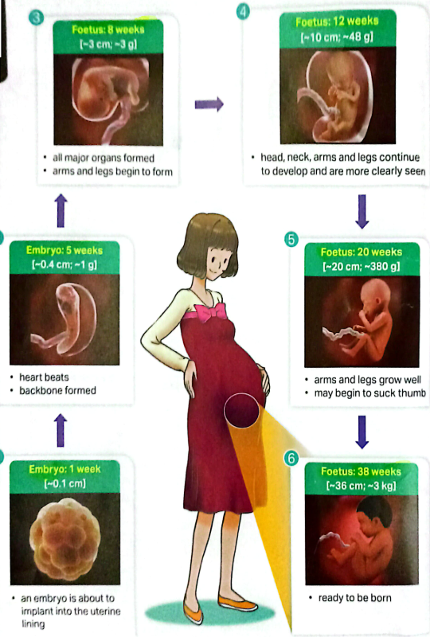
Birth
Labour (the birth giving process) begins in a sign of pain in the abdomen
- Muscles contract strongly
- Amnion breaks
- Watery liquid flows out -> lubricate the vagina
- Opening of the uterus becomes wider
- Baby is pushed out with the head coming out first
- the baby cries and take its first breath
- The doctor clamps and cuts the umbilical cord\
- The placenta is expelled

Puberty
- Everyone is born with a complete set of reproductive organs
- Will be mature for reproduction at puberty
- Starts at 10 or 11 and ends at 18
- Occur earlier in girls
- Body produces sex hormones
- Causes various body changes
  - Secondary sexual characteristic(external features)
    - Male
      - Breads grow
      - Larynx becomes wider and voice becomes deeper
      - Shoulders become wider and the body becomes more muscular
      - Hair grows in pubic area and armpits
    - Female
      - Breasts develop
      - Hair grows in pubic area and armpits
      - Hips becomes wider
  - Signs of sex maturity (start producing sperms and ova develop)
    - Seman may flow out from the penis during sleep-> wet dream
Menstruation
- Menstruation occurs every month
- Some blood will pass through the vagina
Menstrual cycle(28 days)
- Day 1-5: Menstruation: thickened uterine lining break down
- Day 6-10:Uterine lining thickens to prepare for embryo implantation
- Day 14: Ovulation
- Day 15-28: Uterine lining becomes very thick

4.4 being parents

Pregnancy
- Fertilisation + implantation -> pregnant
- Pregnant 38 weeks
Signs of pregnancy
- No menstruation
- Nasua
- Feeling tired easily
- Swollen breasts
- Frequent urination
- Constipation
Health advice during pregnancy
- No
  - Take drug without a doctor’s approval
  - Smoke
  - Drink alcohol
- Yes
  - Maintain a balanced diet
  - Have regular health check-ups
  - Exercise regularly
Length of pregnancy usually increases with the size of the mammal

Parenting
Newborn babies need protection and care
- Need to provide basic necessities
- Guide the baby and teach the baby different basic skills (e.g. how to walk and talk)

Family planning
- Should plan carefully on the number of children and when they want to have children
- Make sure they can give each children enough support and love

Birth control
- May practise birth control to avoid pregnancy

Condom | Acts as a barrier to prevent sperms from reaching the ovum | Male condom: rolled over the penis before intercourse
Condom | Acts as a barrier to prevent sperms from reaching the ovum | Female condom: placed in the vagina of the wife
Diaphragm | Acts as a barrier to prevent sperms from reaching the ovum | Placed at the opening of the uterus
Rhythm method | Without using birth control device | Avoid having sexual intercourse when ovulation so sperms have no chance of meeting the ovum
Sterilization | A permanent surgery | Male: sperm ducts are tied and cut
Sterilization | A permanent surgery | Female: oviducts are tied and cut
Birth control pills | Using sex hormones | Taken by the wife regularly according to doctor’s instruction

Prevent sexually transmitted diseases(STDs)
- Passed through sexual contact
- Using condom can prevent

4.5 hereditary and variation

Passing of traits
- Features each generation inherits from their parents-> traits
- The passing of traits-> hereditary
- Traits: Determined by DNA
- Half from mother and father
- Inherits traits from both parents

Genetic family tree
- Traits can be studied with this
- Trace the passing of traits
- Predict
Symbols commonly used:

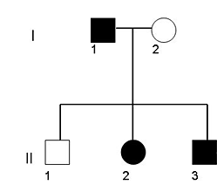
generation
mating
female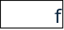male
Youngest (in order)
oldest
male

Variations
- = differences among individuals of a species
Continuous variations
- Continuous range of differences (values)
- E.g. height, body mass, hand span, intelligence quotient (IQ)
- Use histogram to represent
Discontinuous variations
- Clear cut differences (yes/no, types)
- E.g. ear lobes, tongue rollers, blood group, hairline
- Use bar chart to represent

Causes of variations
Heredity (遺傳)
- Inherited variation: determined by hereditary
- Cannot be changed
- Are not affected by the environment
- E.g. eye colour, hair colour, blood group, tongue rolling ability, discontinuous variations
Environment
- Environment variations: variations determined by environment
Both
- Some variations are determined by both
- E.g. Our skin

Twins
Identical twins
- Results from a single zygote
- Zygote spilt into two cells and each developed into a baby
- Have same genetic material
- Can still have variation due to different living environment and habits
Non-identical twins
- Two ova are released and fertilized
- Babies of two pregnancies
- May look different and have different sex

